**CSC 417 Unit 2 Day 6 Outline**

1. Recurrent Neural Networks
   1. 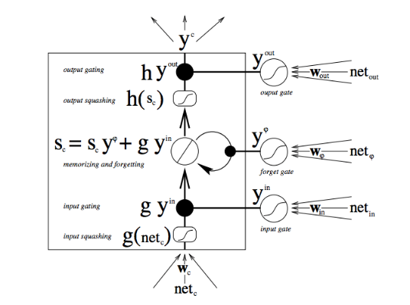Long Short-Term Memory (LSTM)
      1. Three internal gates
         1. Forget gate (remember or forget previous state)
         2. Input gate (allow or block current input)
         3. Output (combine results of previous gates)
      2. Account for both the present input and the past cell state
         1. Previous memory stated multiplied with forget gate
            1. If result = 0, previous memory state (context) forgotten
            2. If result = 1, previous memory state (context) retained/passed on
   2. 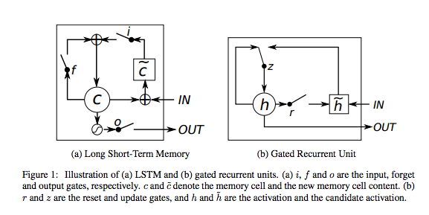Gated Recurrent Unit
      1. Two internal gates
         1. Reset gate (how much of previous state to “keep”)
         2. Update gate (combines input/forget gate from LSTM)
   3. Attention
      1. Multiple RNNs used in a “sequence to sequence” model
         1. One network encodes sequence, other network decodes sequence
      2. In an attention-based approach, encoder RNN sends *all* hidden states to the decoder
      3. Hidden states are scored
      4. Scores put through softmax activation function (amplifies high scores, reduces low scores)
   4. Transformer Networks
      1. Combine CNNs with attention to boost speed of sequence processing
         1. Use multiple encoder/decoders, each utilizing attention
      2. More details in unit on natural language processing
2. Generative Adversarial Networks
3. Generated new data with same *statistics* as training data
   * 1. Does not copy existing members of a category, but creates a new data instance that fits an existing category
   1. Architecture
      1. Generator network creates new data item (based on input random noise)
      2. 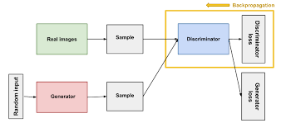Discriminator network attempts to correctly categorize existing real data items and generated data items
4. Philosophy of AI
5. Neural networks seem to be *monointelligences*
   * 1. Perform a single complex task well, but cannot cope with even mundane day to day activities performed by humans
        1. Watson could be humans at Jeopardy – but could Watson perform any human “day to day” activities?